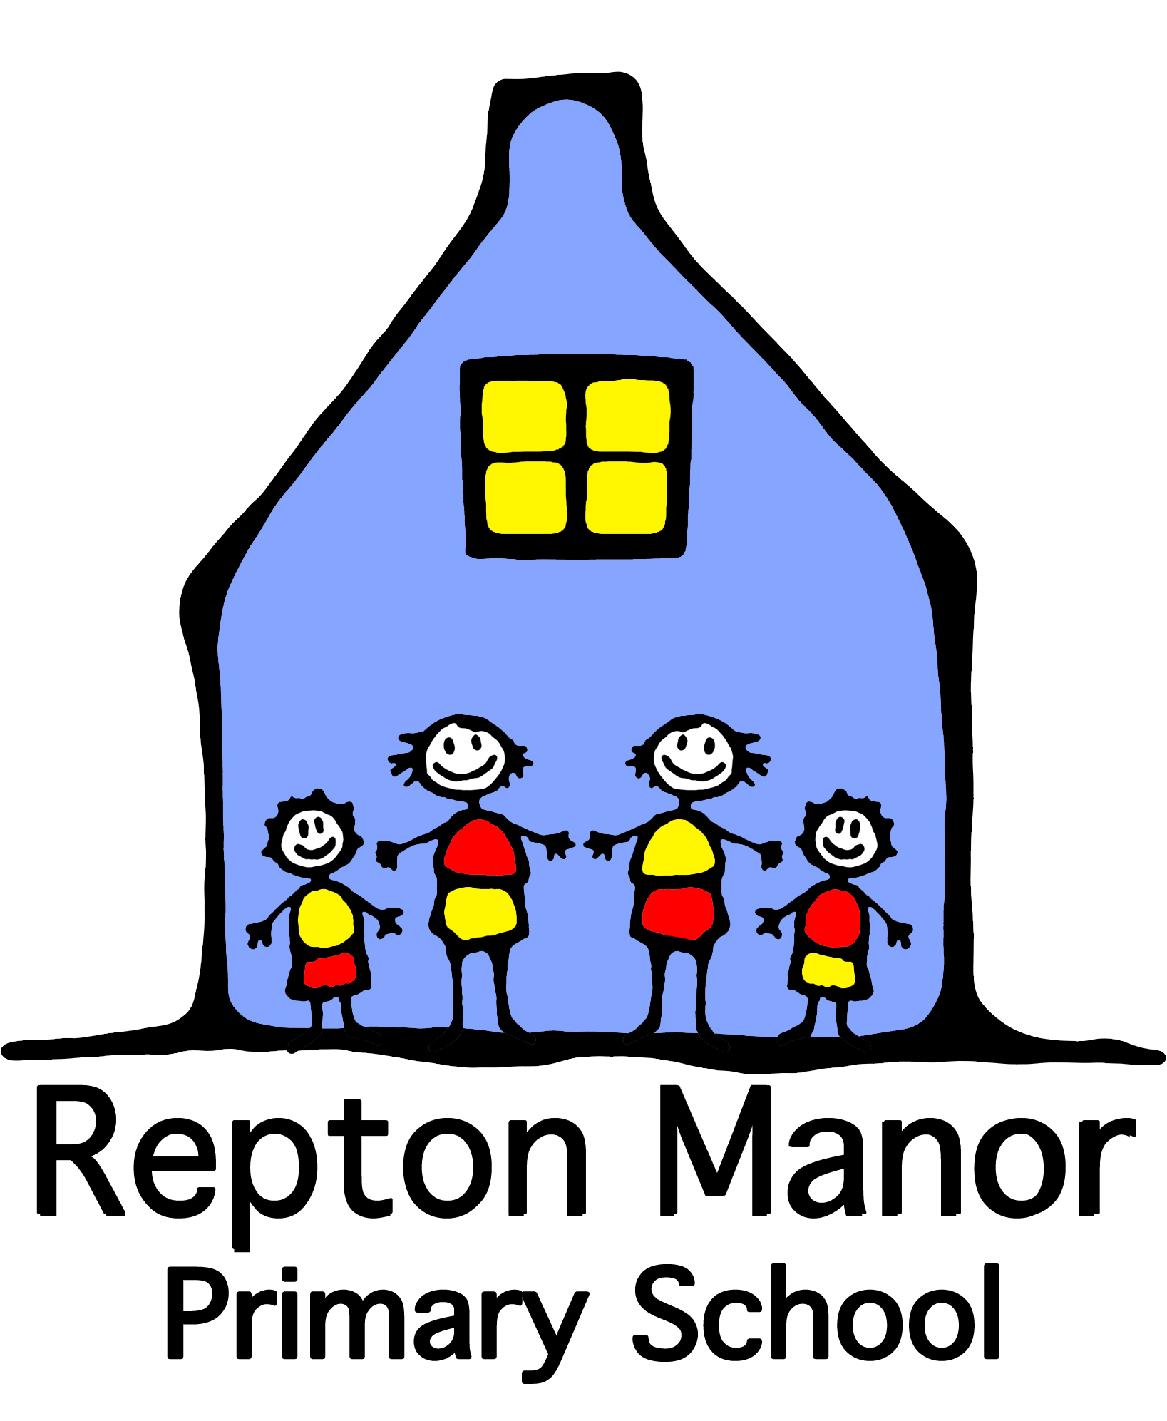

Consent form:
Taking and using
photos/information

Child’s name: Child’s date of birth:

Date:

Dear Parents/Guardians,

At Repton Manor Primary School, we take photographs and film pupils as part of our core activity of education. During your child’s time at Repton Manor Primary School this occurs as part of normal teaching, learning, assessment and safeguarding procedures and as such we do not need permission for these activities.

However, we do seek your permission to take photographs of your child and use them in the ways described below. Please consider carefully the ramification of not granting permission before you decide.

Please tick all the relevant boxes, sign each item below and return this form to the school.

I give my consent for my child’s photo to be stored on Arbor (our school information and communication system) as part of their individual data file.
YES NO Signed……………………………………..

I give consent for my child’s photograph to be taken for the school photographer for individual. Group, class and whole school photographs.
YES NO Signed……………………………………..

I give consent for photos and videos of my child to be used on the school website and/or the school learning platform (Tapestry).
YES NO Signed……………………………………..

I give my consent for photos and the name of my child to appear in local newspapers and magazines. Please note that some newspapers may require the child’s full name and may store photographs for online use.
YES NO Signed……………………………………..

I give my consent for my child to be photographed and filmed by staff and fellow parents during school productions and events as long as it is made clear each time that these must be used for personal viewing purposes and must not be published in any format including on-line.
YES NO Signed……………………………………..

I give my consent for my child’s image to be used for identification purposes should they have a specific educational, dietary or medical need which needs to be communicated to all staff for safeguarding purposes (These photographs will be displayed in the medical room, staff room and school kitchen only).
YES NO Signed……………………………………..

I give my consent for my child’s named image to be taken by the adult in charge on school trips or visits (The image would only be used in the event of an emergency and is shredded on return to school)
YES NO Signed……………………………………..

I give permission for my child to participate in video conferencing (Occasionally your child’s class may talk to other children or an author for example, outside of school under the supervision of their class teacher)
YES NO Signed……………………………………..

I give permission for my child to be part of a class list (First name only) to be given, on request, to parents who would like to invite my child to parties or for Christmas cards.

Please note: This form is valid for the period of time your child is on roll at Repton Manor Primary School. Where the consent is given for a specific reason e.g. a trip, medical condition etc once the need ends he image will be destroyed by shredding.

If you have any questions regarding consents or wish to make any changes, please email the school office at office@reptonmanor.kent.sch.uk or call the school on 01233 666307.

Why do we ask for consent?
You may be aware that there were new data protection rules introduced in May 2018. To ensure Repton Manor Primary School meets the new requirements, we need to obtain your consent under the new regulations to take and use photos and/or information of your child.

We really value using photos of your child to showcase what they do in school and demonstrate what school life is like to other stakeholders and the wider community, so we really appreciate you taking the time to give your consent.

Furthermore, it is hugely beneficial to be able to identify children with educational, dietary or medical needs to all staff, to safeguard and ensure their wellbeing.

Mrs Jackie Chambers
Head of School

Parent/carer signature: __________________________________________

Date: __________________________________________

Relationship to child: __________________________________________

